TELCO CUSTOMER CHURN ANALYSIS
Submitted by: Himanshu Pandey
Organisation: Meritsoft
Submission Date: 22 April 2026

1. Executive Summary & Business Context
Customer retention is a critical profitability driver for subscription-based telecommunications companies. Customer churn directly reduces recurring revenue while increasing acquisition and operational costs.
This engagement was conducted to analyse customer behaviour, identify churn drivers, and develop actionable strategies for improving retention performance.
Business Problem
Management lacks clear visibility into:
- Which customers are most likely to churn
- Key behavioural and financial drivers of attrition
- How retention initiatives should be prioritized
Project Objective
Develop a data-driven framework to:
- Understand churn behaviour
- Identify high-risk customer segments
- Predict churn likelihood
- Enable proactive retention decision-making
Headline Findings
- Overall churn rate: 26.58%
- Nearly 1 in 4 customers leave the service
- Month-to-month contracts drive highest churn risk
- Higher monthly pricing correlates with churn
- Customer loss occurs primarily in early lifecycle stages
Business Outcome
The analysis provides management with a structured analytical foundation to transition from reactive customer loss toward predictive retention management.

2. Dataset Overview
The Telco dataset contains customer demographic, service usage, billing, and contractual information.
Metric | Value
Total Customers | 7043
Variables | 21
Target Variable | Churn

Data Categories
- Demographics
- Services subscribed
- Contract details
- Billing & revenue data

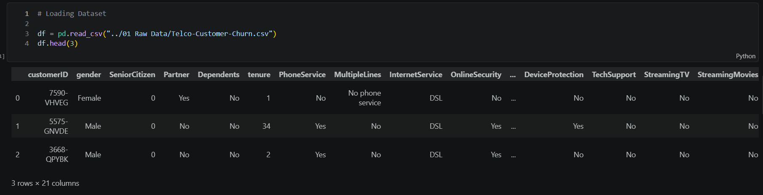
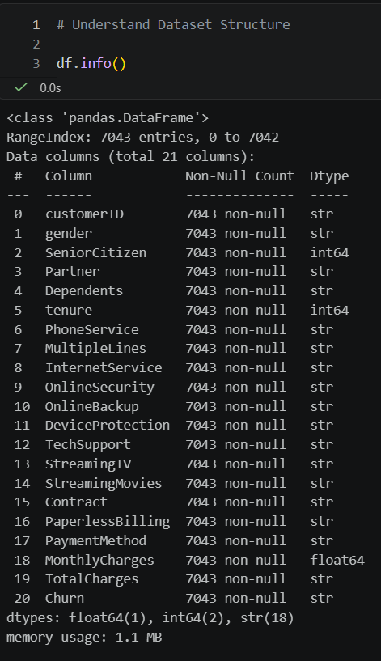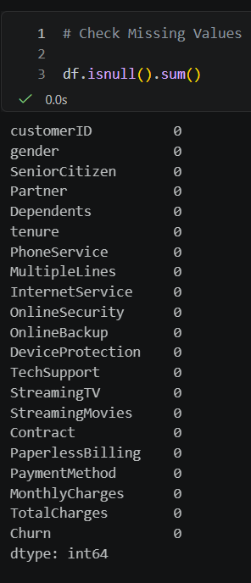

3. Analytical Methodology
The analysis followed a structured end-to-end analytics workflow designed to convert raw operational data into actionable business intelligence.
The methodology mirrors real-world engagements where analytical work progresses through sequential decision stages.

Stage 1 — Data Understanding
Objective: Establish familiarity with available business data.
Activities:
- Reviewed dataset structure and variables
- Identified customer demographic, behavioural, financial, and contractual attributes
- Defined the target variable (Churn) representing customer attrition
Why this matters
Consultants must first understand how business operations are reflected in data before performing analysis.

Stage 2 — Data Cleaning & Preparation
Objective: Ensure analytical reliability.
Activities:
- Corrected data types (e.g., TotalCharges conversion to numeric)
- Detected hidden missing values
- Removed incomplete records
- Validated dataset consistency
Business Importance
Poor data quality leads to misleading business decisions.

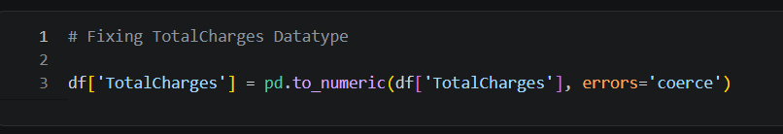

Stage 3 — Exploratory Data Analysis (EDA)
Objective: Discover behavioural patterns influencing churn.
Techniques:
- Distribution analysis
- Group comparisons
- Aggregated churn rate calculations
- Relationship visualization between variables and churn
Purpose
Identify early hypotheses regarding churn drivers.

Stage 4 — Customer Segmentation
Objective: Translate analysis into actionable business groups.
Approach:
- Classified customers into High-Risk and Loyal segments
- Used tenure, pricing, and contract behaviour indicators
Business Value
Enables targeted retention strategies instead of generic marketing interventions.

Stage 5 — Predictive Modelling
Objective: Move from descriptive insights to predictive capability.
Method:
- Logistic Regression model
- Iterative optimization until convergence (v1.0 ~5000 iterations, v2.0 ~1000 iterations)
Outcome:
- Estimated churn probability for customers
- Supported proactive decision-making

Stage 6 — Business Intelligence Dashboard Development
Objective: Deliver insights in an executive decision format.
Implementation:
- Interactive dashboard built using Power BI Desktop (Free Edition)
- KPI monitoring and churn driver visualization
Goal
Ensure analytical insights translate into operational use.

4. Data Preparation
Cleaning ensured analytical accuracy.
Actions:
- Corrected datatype issues
- Removed incomplete rows
- Prepared final clean dataset
Outcome:
Reliable dataset for analysis and modelling.

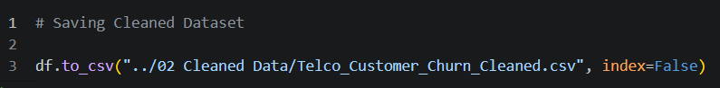
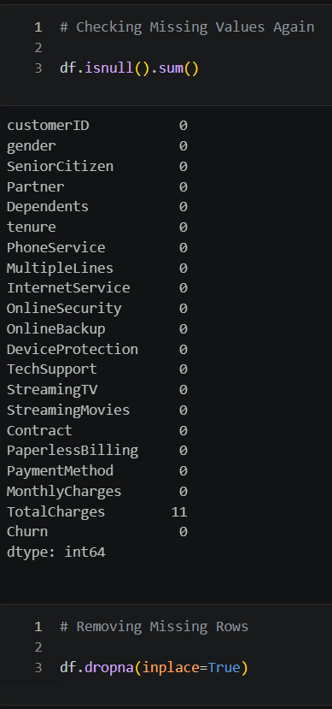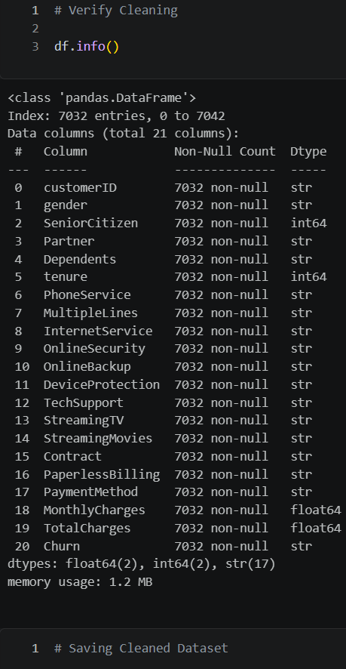

5. Exploratory Business Analysis

5.1 Overall Churn Distribution
- Retained Customers: 73.42%
- Churned Customers: 26.58%
Business Insight:
High churn indicates retention opportunity.

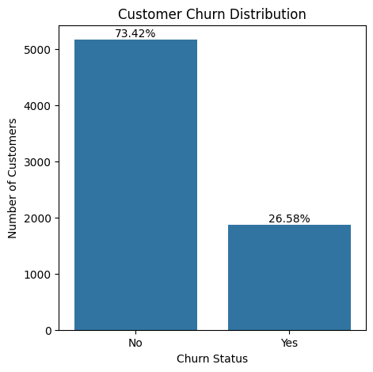

5.2 Contract Type vs Churn
Contract | Churn Rate
Month-to-Month | 42.71%
One Year | 11.28%
Two Year | 2.85%
Insight:
Long-term commitment dramatically reduces churn.

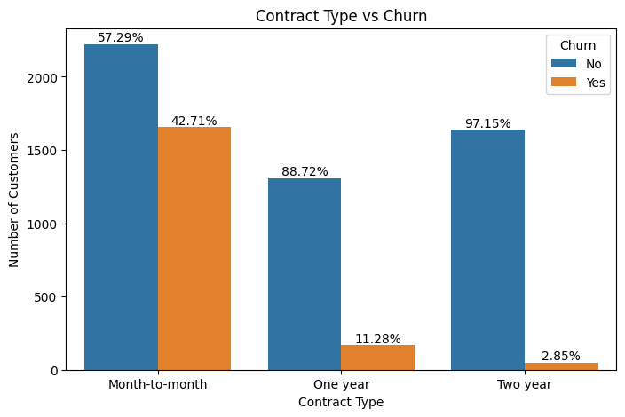

5.3 Monthly Charges vs Churn
Average Monthly Charges:
- Non-Churn: 61.31
- Churn: 74.44
Insight:
Higher-paying customers demonstrate higher churn risk.

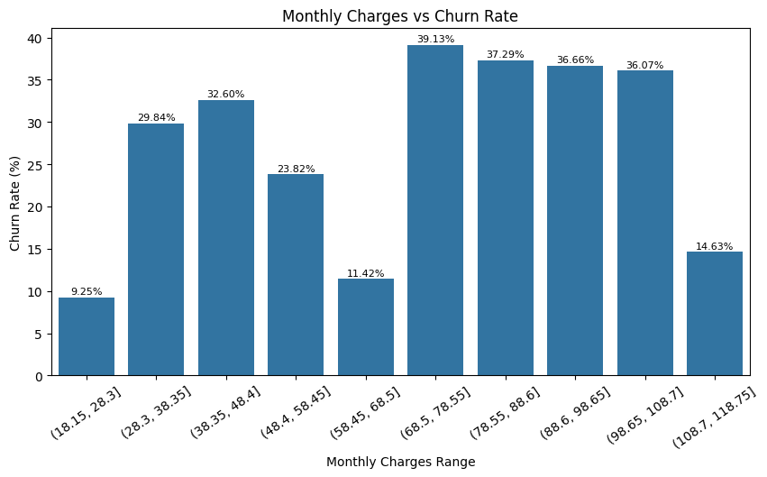

5.4 Tenure vs Churn
Observation:
- New customers churn early
- Long-tenure customers remain loyal

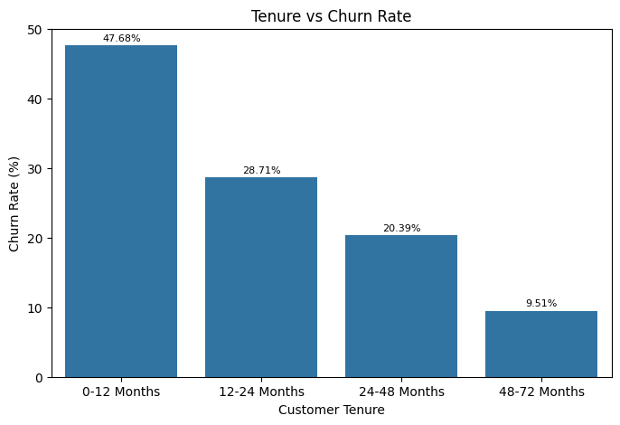

6. Customer Segmentation
High-Risk Customers
Count: 814
- Short tenure
- High charges
- Flexible contracts

Loyal Customers
Count: 2689
- Long tenure
- Stable payments
- Contract commitment

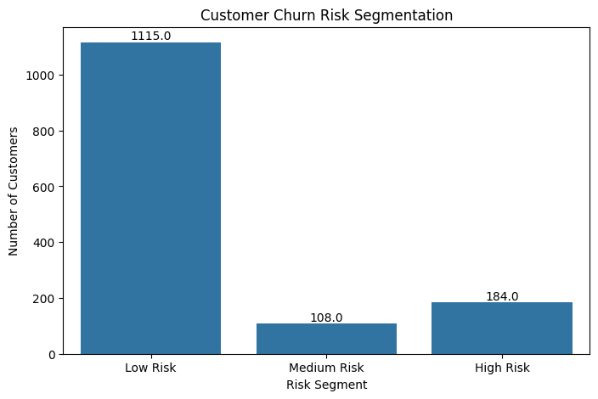

7. Key Performance Indicators
KPI | Value
Churn Rate | 26.58%
ARPU | 64.80
Business Meaning:
Retention improvement yields direct financial benefit.

8. Predictive Modelling
Model Used:
- Logistic Regression
Performance:
- Accuracy: ~80%
- Full Convergence achieved around 4500 iterations
Insights:
Customer churn behaviour is predictable using historical data.

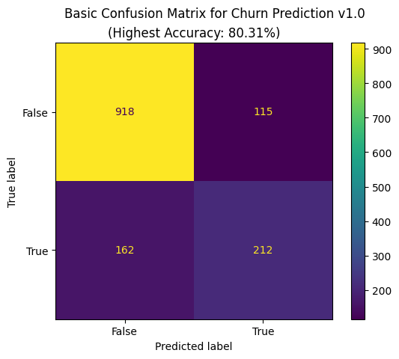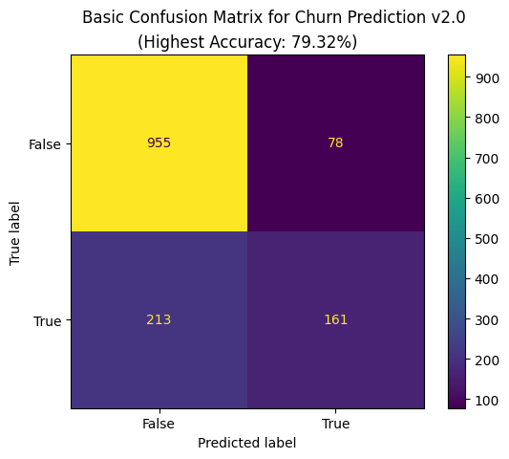
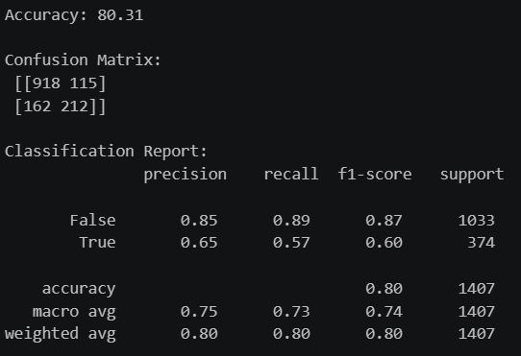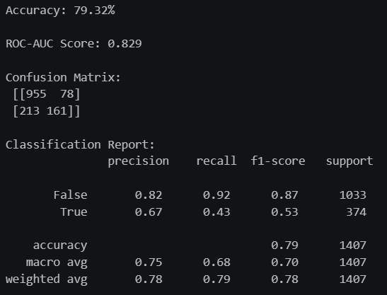

9. Power BI Dashboard Development
Dashboard designed for executive decision-making.

Dashboard Pages
Executive Overview
- Total customers
- Churn KPI
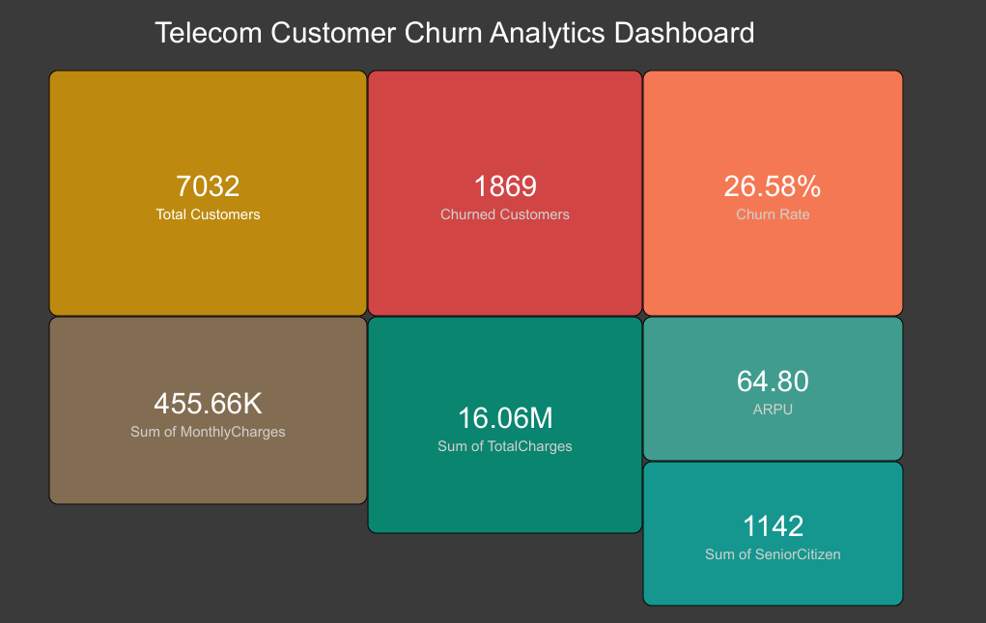

Churn Drivers
- Contract impact
- Pricing influence
- Tenure behaviour
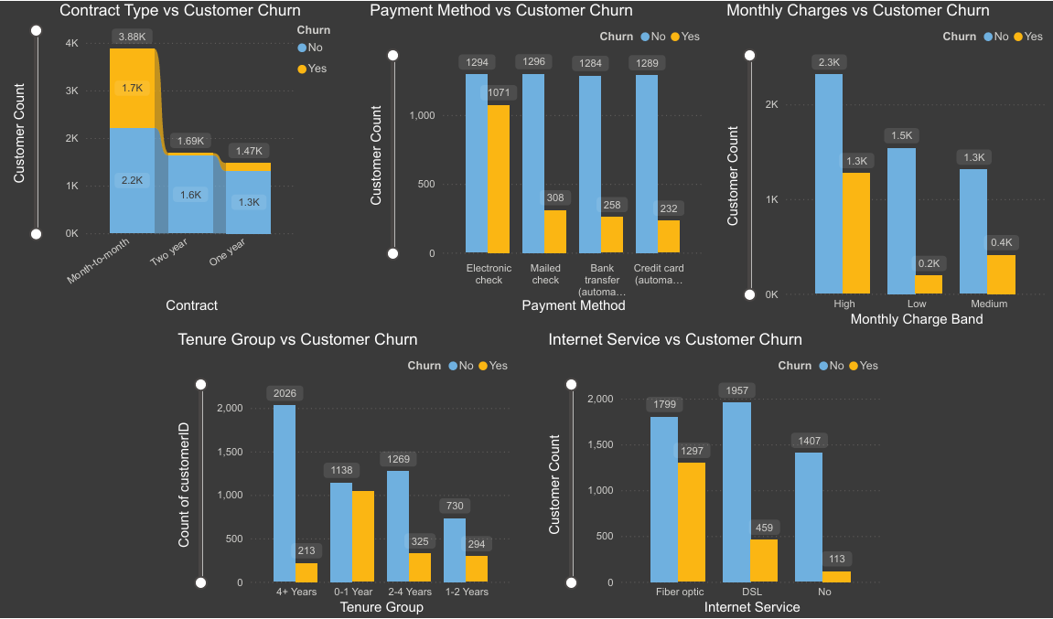

Customer Segmentation
- High Risk vs Loyal
- Service adoption patterns
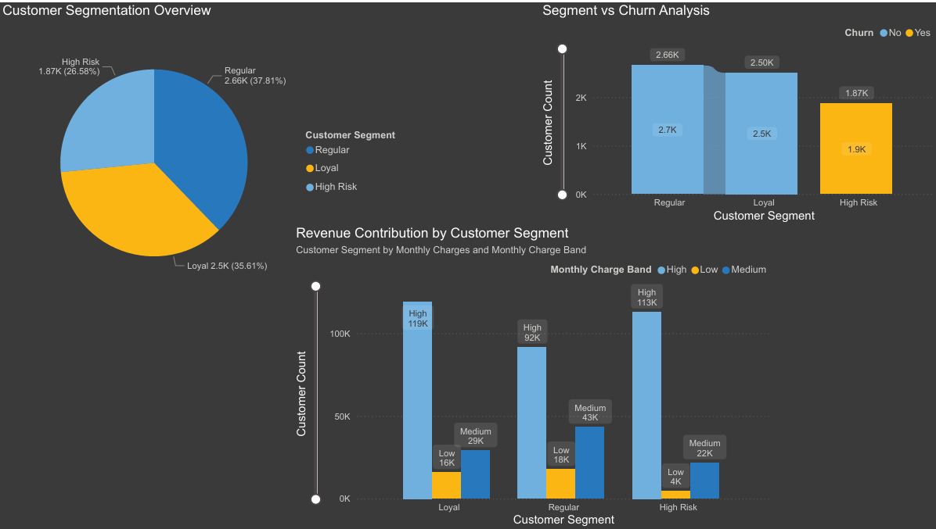

10. Key Business Insights
- Contract flexibility is primary churn driver.
- Pricing sensitivity influences customer retention.
- Early lifecycle customers require intervention.
- Engagement through bundled services improves loyalty.
- Predictive analytics enables proactive retention.

11. Strategic Recommendations
Immediate Actions
- Incentivize annual contracts
- Improve onboarding engagement
- Target high-charge customers
Medium-Term Actions
- Deploy churn prediction alerts
- Personalize service bundles
Long-Term Strategy
- Integrate analytics into CRM operations
- Transition to predictive retention management

12. Assumptions & Limitations
Assumptions
- Dataset reflects operational reality
- Historical patterns remain valid
Limitations
- External market factors unavailable
- Limited feature set

13. Business Impact
Reducing churn from 26.58% to 22% could significantly increase revenue stability and customer lifetime value.

14. Conclusion
Customer churn is not random behaviour — it is analytically explainable and strategically manageable.
Organizations adopting data-driven retention frameworks transition from reactive customer loss toward proactive customer success management.

